OPPORTUNITY FOR FINISHING ICONS under the direction of master iconographer Dmitri Andrejev
Just in time for All Saints’ Day bring your unfinished icons for a three day finishing workshop. All those saints and angels can be finished, oiled and blessed this year. I am really looking forward to accomplishing this challenge.
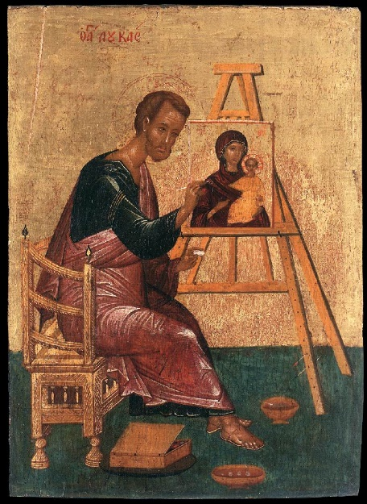
THURSDAY FRIDAY SATURDAY OCTOBER 26, 27 AND 28, 2017 at St. Mary’s Church on Lancaster Avenue in Wayne, PA from 9 – 4 daily. Bring your icons, we will supply pigments and tools so no need to pack up your studio. This will be a pre-Advent time of icon finishing and fellowship. What a way to complete the liturgical year!
Cost: $250 Tuition
$6 Materials
$65 Workshop expenses (teacher travel, housing and meals, church room rent etc)
Total for the three days $321.

Minimum of 8 students needed to run the class- Maximum of 10

Please send your deposit* of $200 made out to Dmitri Andrejev to hold your place
Send to: Susan Kelly vonmedicus 408 Skippack Pike Fort Washington PA 19034
*deposits are non-refundable in event of student cancellation, if class is cancelled by teacher for any reason such as low enrollment, deposits will be refunded.

